**Отчёт**

**Некластерный составной индекс**

1, 2) Соединения, фильтрация данных:

Код запроса:

SELECT e.ID_employee, e.FirstName, e.PhoneNumber

FROM Employees AS e

INNER JOIN Gyms AS g

ON e.ID_gym = g.ID_gym

AND PhoneNumber LIKE N'%1'

CREATE NONCLUSTERED INDEX idx1_1 ON Employees(PhoneNumber, FirstName)

CREATE NONCLUSTERED INDEX idx1_2 ON Gyms(ID_gym)

SELECT e.ID_employee, e.FirstName, e.PhoneNumber

FROM Employees AS e

INNER JOIN Gyms AS g

ON e.ID_gym = g.ID_gym

AND PhoneNumber LIKE N'%1'

DROP INDEX idx1_1 ON Employees

DROP INDEX idx1_2 ON Gyms

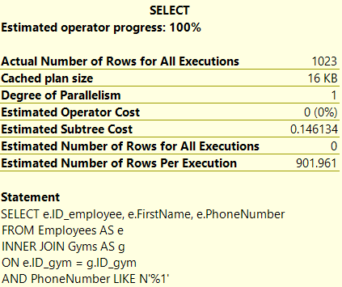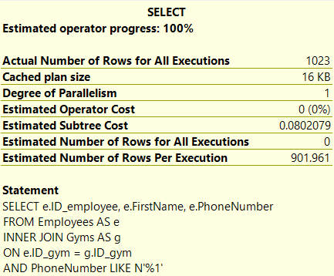

3) Работа со строками

SELECT cl.ID_client, REPLACE(cl.BirthDate, N'-', N'.') AS newDate

FROM Clients AS cl

CREATE NONCLUSTERED INDEX idx1_3 ON Clients(BirthDate, ID_client)

SELECT cl.ID_client, REPLACE(cl.BirthDate, N'-', N'.') AS newDate

FROM Clients AS cl

DROP INDEX idx1_3 ON Clients

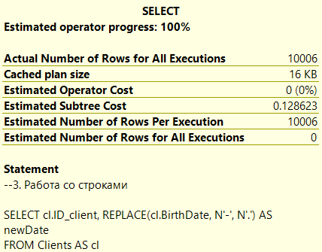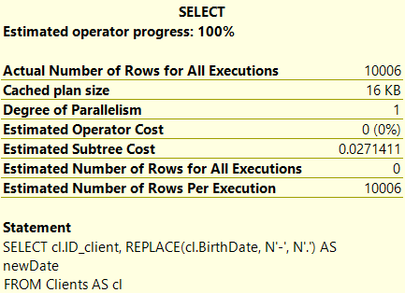

4) Дата и время

SELECT c.ID_coach, DATEPART(yy, c.BirthDate)

FROM Coaches AS c

CREATE NONCLUSTERED INDEX idx1_4 ON Coaches(BirthDate, ID_coach)

SELECT c.ID_coach, DATEPART(yy, c.BirthDate)

FROM Coaches AS c

DROP INDEX idx1_4 ON Coaches

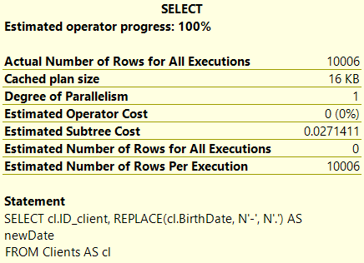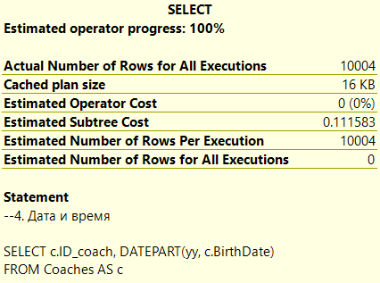  
  
5) Агрегатные функции, группировка

SELECT g.Address, COUNT(g.Title)

FROM Gyms AS g

GROUP BY g.Address

CREATE NONCLUSTERED INDEX idx1_5 ON Gyms(Address, Title)

SELECT g.Address, COUNT(g.Title)

FROM Gyms AS g

GROUP BY g.Address

DROP INDEX idx1_5 ON Gyms

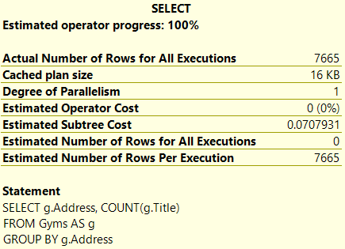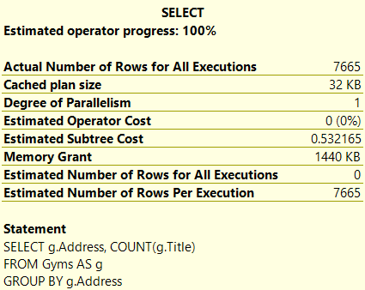

6) Вложенный запрос

SELECT e.Occupation, e.BirthDate

FROM Employees AS e

WHERE e.BirthDate IN (

SELECT e.BirthDate

FROM Employees AS e

WHERE e.BirthDate BETWEEN '1975-01-01' AND '1990-12-31'

)

CREATE NONCLUSTERED INDEX idx1_6 ON Employees(BirthDate, ID_employee, Occupation)

SELECT e.Occupation, e.BirthDate

FROM Employees AS e

WHERE e.Birthdate IN (

SELECT e.Birthdate

FROM Employees AS e

WHERE e.BirthDate BETWEEN '1975-01-01' AND '1990-12-31'

)

DROP INDEX idx1_6 ON Employees

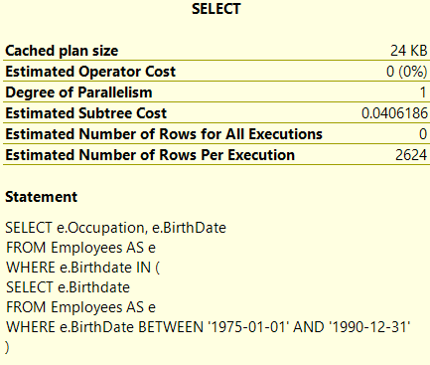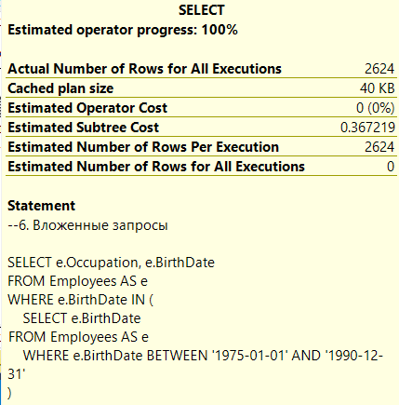

7) Объединение и пересечение

SELECT e.Firstname

FROM Employees AS e

WHERE Firstname LIKE 'А%'

UNION

SELECT e.Lastname

FROM Employees AS e

WHERE Lastname LIKE 'а%'

CREATE NONCLUSTERED INDEX idx1_7 ON Employees(Firstname, Lastname)

SELECT e.Firstname

FROM Employees AS e

WHERE Firstname LIKE 'А%'

UNION

SELECT e.Lastname

FROM Employees AS e

WHERE Lastname LIKE 'а%'

DROP INDEX idx1_7 ON Employees

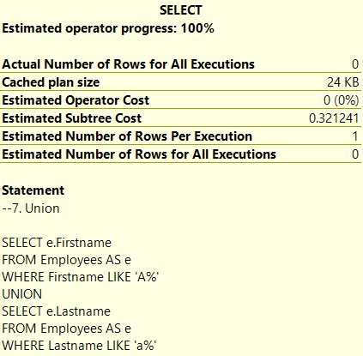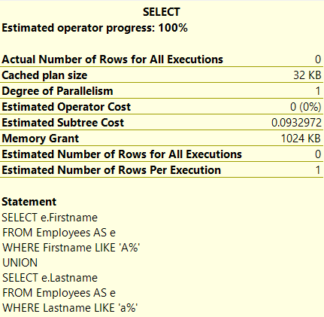

**Некластерный индекс с включёнными столбцами**

1) Соединение

SELECT g.Title, inv.ItemName FROM Inventory AS inv

FULL JOIN Gyms as g

ON inv.ID_gym = g.ID_gym

CREATE NONCLUSTERED INDEX idx2_1 ON Gyms(ID_gym) INCLUDE (Title)

SELECT g.Title, inv.ItemName FROM Inventory AS inv

FULL JOIN Gyms as g

ON inv.ID_gym = g.ID_gym

DROP INDEX idx2_1 ON Gyms

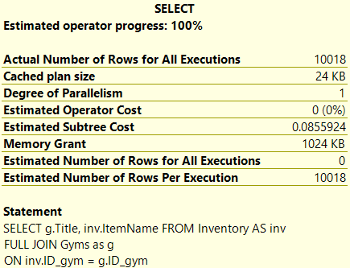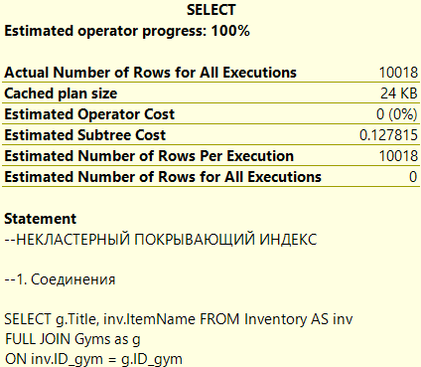

2) Фильтрация

SELECT c.Firstname, c.Surname, c.Rating

FROM Coaches AS c

WHERE Rating BETWEEN 3.0 AND 4.5

CREATE NONCLUSTERED INDEX idx2_2 ON Coaches(Rating) INCLUDE (Firstname, Surname)

SELECT c.Firstname, c.Surname, c.Rating

FROM Coaches AS c

WHERE Rating BETWEEN 3.0 AND 4.5

DROP INDEX idx2_2 ON Coaches

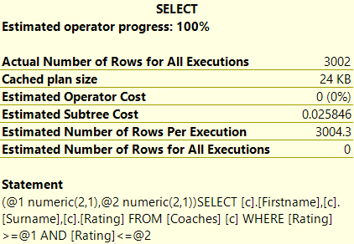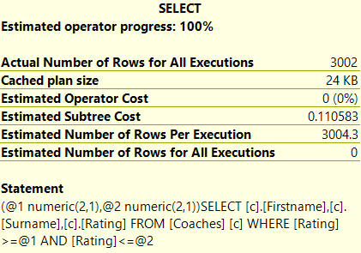

3) Строки

SELECT STUFF(cl.Firstname, 1, 3, '___'), cl.Lastname

FROM Clients AS cl

CREATE NONCLUSTERED INDEX idx2_3 ON Clients(Firstname) INCLUDE (Lastname)

SELECT STUFF(cl.Firstname, 1, 3, '___'), cl.Lastname

FROM Clients AS cl

DROP INDEX idx2_3 ON Clients

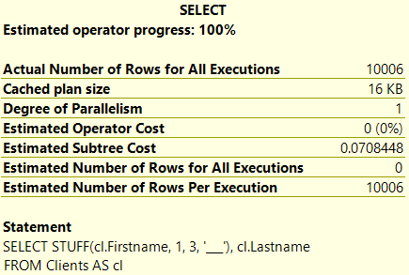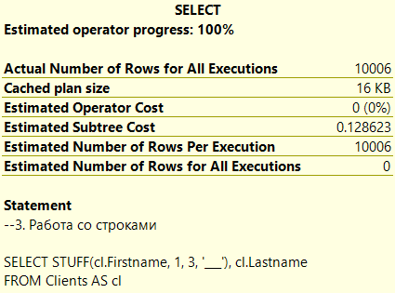

4) Дата и время

SELECT e.Firstname, e.Surname

FROM Employees AS e

WHERE DATEDIFF(year, '2024/01/01', e.BirthDate) > 25

CREATE NONCLUSTERED INDEX idx2_4 ON Employees(BirthDate) INCLUDE (Firstname, Surname)

SELECT e.Firstname, e.Surname

FROM Employees AS e

WHERE DATEDIFF(year, '2024/01/01', e.BirthDate) > 25

DROP INDEX idx2_4 ON Employees

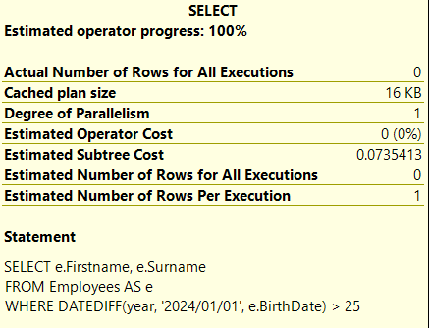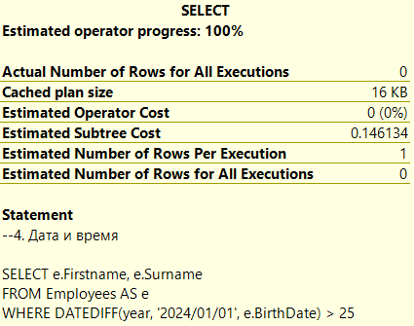

5) Агрегация данных

SELECT COUNT(Price), tar.Title

FROM Tariffs AS tar

GROUP BY Title

CREATE NONCLUSTERED INDEX idx2_5 ON Tariffs(Title) INCLUDE (Price)

SELECT COUNT(Price), tar.Title

FROM Tariffs AS tar

GROUP BY Title

DROP INDEX idx2_5 ON Tariffs

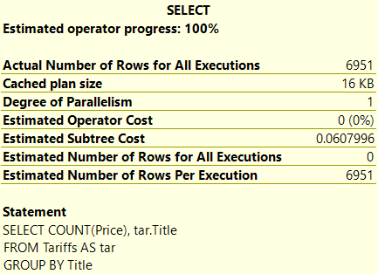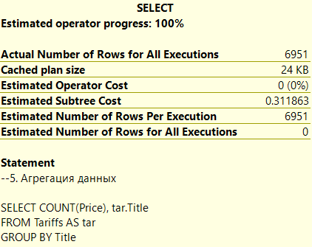

6) Вложенные запросы

SELECT c.Firstname, c.Surname, c.Rating

FROM Coaches AS c

WHERE Rating >= ANY

(SELECT c.Rating

FROM Coaches

WHERE c.Firstname = 'аа')

CREATE NONCLUSTERED INDEX idx2_6 ON Coaches(Firstname) INCLUDE (Rating, Surname)

SELECT c.Firstname, c.Surname, c.Rating

FROM Coaches AS c

WHERE Rating >= ANY

(SELECT c.Rating

FROM Coaches

WHERE c.Firstname = 'аа')

DROP INDEX idx2_6 ON Coaches

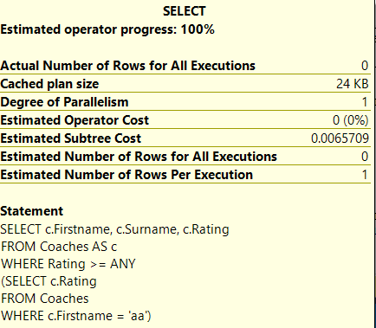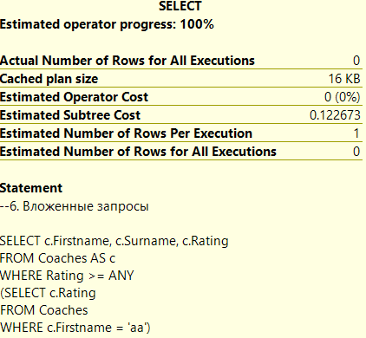

7) Intersect

SELECT c.Firstname

FROM Coaches AS c

WHERE SUBSTRING(c.Firstname,5,1) = 'в'

INTERSECT

SELECT c.Lastname

FROM Coaches AS c

WHERE SUBSTRING(c.Lastname,3,1) = 'А'

CREATE NONCLUSTERED INDEX idx2_7 ON Coaches(Firstname) INCLUDE (Lastname)

SELECT c.Firstname

FROM Coaches AS c

WHERE SUBSTRING(c.Firstname,5,1) = 'в'

INTERSECT

SELECT c.Lastname

FROM Coaches AS c

WHERE SUBSTRING(c.Lastname,3,1) = 'А'

DROP INDEX idx2_7 ON Coaches

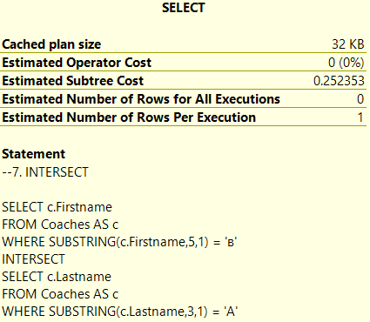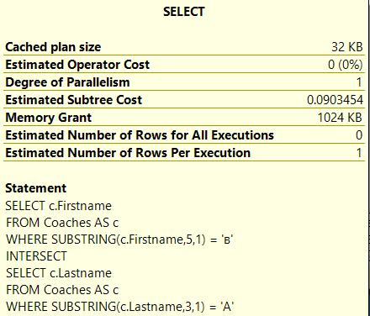

**Некластерный покрывающий индекс**

1) Соединение

SELECT g.Title, inv.ItemName FROM Inventory AS inv

FULL JOIN Gyms as g

ON inv.ID_gym = g.ID_gym

CREATE NONCLUSTERED INDEX idx2_1 ON Gyms(ID_gym, Title)

SELECT g.Title, inv.ItemName FROM Inventory AS inv

FULL JOIN Gyms as g

ON inv.ID_gym = g.ID_gym

DROP INDEX idx2_1 ON Gyms



2) Фильтрация

SELECT c.Firstname, c.Surname, c.Rating

FROM Coaches AS c

WHERE Rating BETWEEN 3.0 AND 4.5

CREATE NONCLUSTERED INDEX idx2_2 ON Coaches(Rating, Firstname, Surname)

SELECT c.Firstname, c.Surname, c.Rating

FROM Coaches AS c

WHERE Rating BETWEEN 3.0 AND 4.5

DROP INDEX idx2_2 ON Coaches



3) Строки

SELECT STUFF(cl.Firstname, 1, 3, '___'), cl.Lastname

FROM Clients AS cl

CREATE NONCLUSTERED INDEX idx2_3 ON Clients(Firstname, Lastname)

SELECT STUFF(cl.Firstname, 1, 3, '___'), cl.Lastname

FROM Clients AS cl

DROP INDEX idx2_3 ON Clients



4) Дата и время

SELECT e.Firstname, e.Surname

FROM Employees AS e

WHERE DATEDIFF(year, '2024/01/01', e.BirthDate) > 25

CREATE NONCLUSTERED INDEX idx2_4 ON Employees(BirthDate, Firstname, Surname)

SELECT e.Firstname, e.Surname

FROM Employees AS e

WHERE DATEDIFF(year, '2024/01/01', e.BirthDate) > 25

DROP INDEX idx2_4 ON Employees



5) Агрегация данных

SELECT COUNT(Price), tar.Title

FROM Tariffs AS tar

GROUP BY Title

CREATE NONCLUSTERED INDEX idx2_5 ON Tariffs(Title, Price)

SELECT COUNT(Price), tar.Title

FROM Tariffs AS tar

GROUP BY Title

DROP INDEX idx2_5 ON Tariffs



6) Вложенные запросы

SELECT c.Firstname, c.Surname, c.Rating

FROM Coaches AS c

WHERE Rating >= ANY

(SELECT c.Rating

FROM Coaches

WHERE c.Firstname = 'аа')

CREATE NONCLUSTERED INDEX idx2_6 ON Coaches(Firstname, Rating, Surname)

SELECT c.Firstname, c.Surname, c.Rating

FROM Coaches AS c

WHERE Rating >= ANY

(SELECT c.Rating

FROM Coaches

WHERE c.Firstname = 'аа')

DROP INDEX idx2_6 ON Coaches



7) Intersect

SELECT c.Firstname

FROM Coaches AS c

WHERE SUBSTRING(c.Firstname,5,1) = 'в'

INTERSECT

SELECT c.Lastname

FROM Coaches AS c

WHERE SUBSTRING(c.Lastname,3,1) = 'А'

CREATE NONCLUSTERED INDEX idx2_7 ON Coaches(Firstname, Lastname)

SELECT c.Firstname

FROM Coaches AS c

WHERE SUBSTRING(c.Firstname,5,1) = 'в'

INTERSECT

SELECT c.Lastname

FROM Coaches AS c

WHERE SUBSTRING(c.Lastname,3,1) = 'А'

DROP INDEX idx2_7 ON Coaches



**Некластерный уникальный индекс**

1) Соединения

SELECT cl.Firstname, lock.LockerNumber FROM Clients AS cl

LEFT JOIN Lockers AS lock

ON cl.ID_client = lock.ID_client

CREATE UNIQUE NONCLUSTERED INDEX idx3_1 ON Clients(Firstname, ID_client)

SELECT cl.Firstname, lock.LockerNumber FROM Clients AS cl

LEFT JOIN Lockers AS lock

ON cl.ID_client = lock.ID_client

DROP INDEX idx3_1 ON Clients

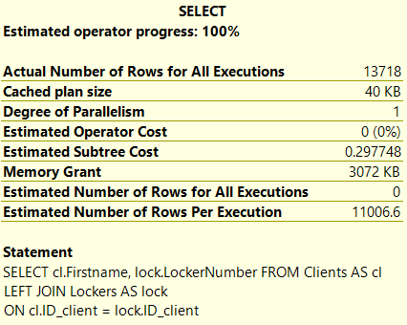 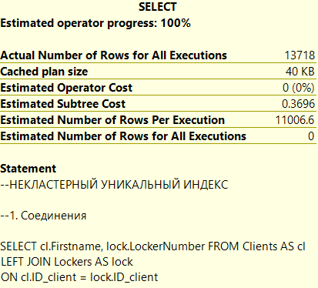

2) Использование предикатов

SELECT c.Firstname, c.Lastname, c.Surname

FROM Coaches AS c

WHERE c.Surname IS NULL

CREATE UNIQUE NONCLUSTERED INDEX idx3_2 ON Coaches(Surname, ID_coach)

SELECT c.Firstname, c.Lastname, c.Surname

FROM Coaches AS c

WHERE c.Surname IS NULL

DROP INDEX idx3_2 ON Coaches

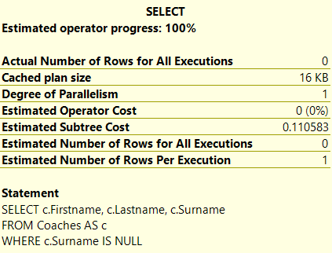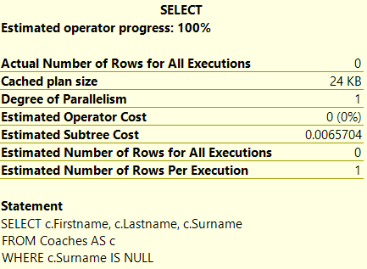

3) Работа со строками

SELECT STUFF(e.Firstname, 0, 4, 'NEW_NAME_')

FROM Employees AS e

CREATE UNIQUE NONCLUSTERED INDEX idx3_3 ON Employees(Firstname, ID_employee)

SELECT STUFF(e.Firstname, 0, 4, 'NEW_NAME_')

FROM Employees AS e

DROP INDEX idx3_3 ON Employees  
  
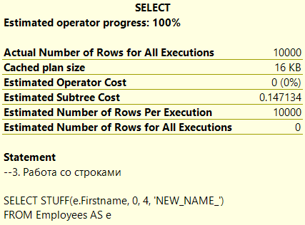 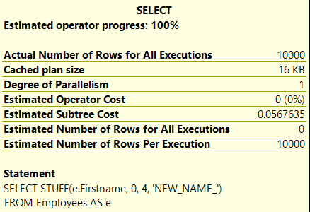

4) Дата и время

SELECT DATEDIFF(day, e.BirthDate, GETDATE())

FROM Employees AS e

CREATE UNIQUE NONCLUSTERED INDEX idx3_4 ON Employees(Birthdate, ID_employee)

SELECT DATEDIFF(day, e.BirthDate, GETDATE())

FROM Employees AS e

DROP INDEX idx3_4 ON Employees

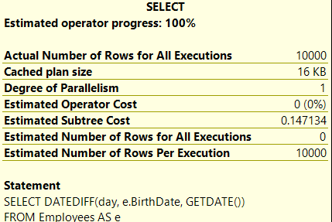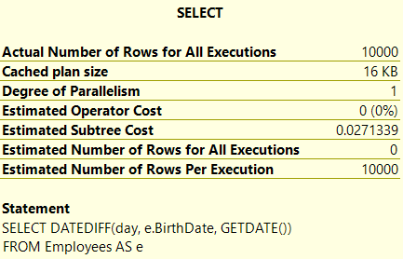

5) Агрегатные функции

SELECT l.LockerNumber, COUNT(l.LockerNumber)

FROM Lockers AS l

WHERE LockerNumber > 40

GROUP BY LockerNumber

ORDER BY LockerNumber

CREATE UNIQUE NONCLUSTERED INDEX idx3_5 ON Lockers(LockerNumber, ID_locker)

SELECT l.LockerNumber, COUNT(l.LockerNumber)

FROM Lockers AS l

WHERE LockerNumber > 40

GROUP BY LockerNumber

ORDER BY LockerNumber

DROP INDEX idx3_5 ON Lockers

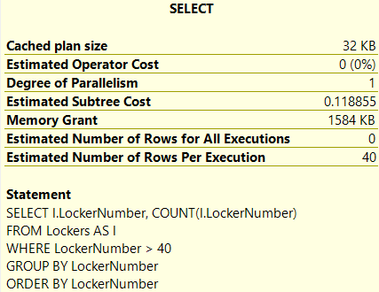 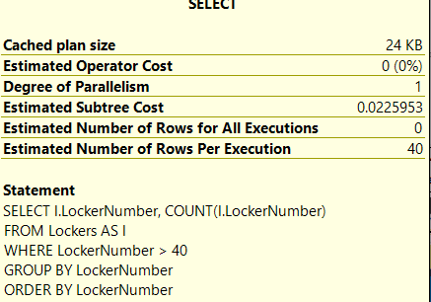

6) Вложенные запросы

SELECT e.Occupation, e.BirthDate

FROM Employees AS e

WHERE Occupation IN

(SELECT Occupation

FROM Employees AS e

WHERE LEN(Occupation) > 5)

CREATE UNIQUE INDEX idx3_6 ON Employees(ID_employee, Occupation)

SELECT e.Occupation, e.BirthDate

FROM Employees AS e

WHERE Occupation IN

(SELECT Occupation

FROM Employees AS e

WHERE LEN(Occupation) > 5)

DROP INDEX idx3_6 ON Employees

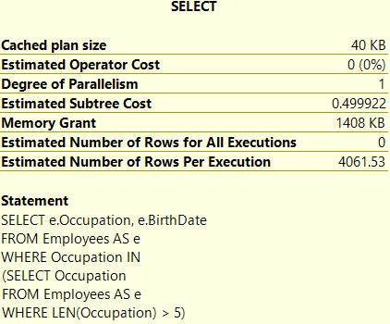 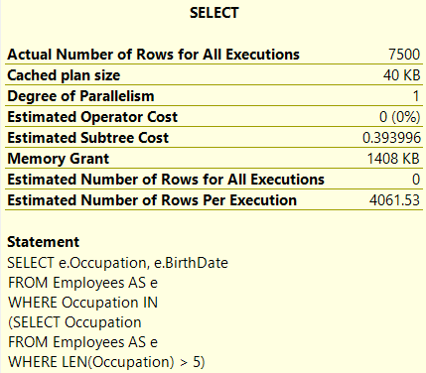

7) Union

SELECT c.Lastname, c.Rating

FROM Coaches AS c

WHERE c.Rating BETWEEN 1.0 AND 2.0

UNION

SELECT c.Lastname, c.Rating

FROM Coaches AS c

WHERE c.Rating BETWEEN 4.0 AND 5.0

CREATE UNIQUE NONCLUSTERED INDEX idx3_7 ON Coaches(Rating, Lastname)

SELECT c.Lastname, c.Rating

FROM Coaches AS c

WHERE c.Rating BETWEEN 1.0 AND 2.0

UNION

SELECT c.Lastname, c.Rating

FROM Coaches AS c

WHERE c.Rating BETWEEN 4.0 AND 5.0

DROP INDEX idx3_7 ON Coaches

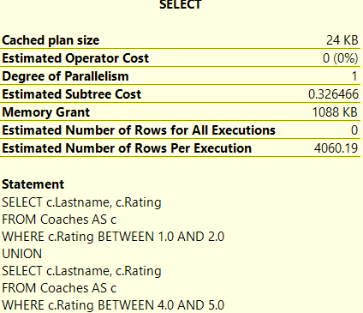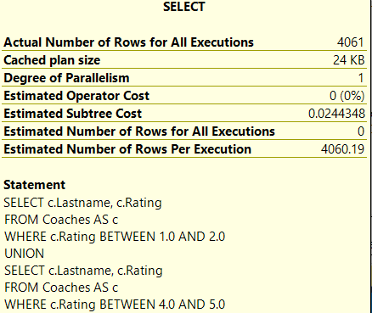

**Некластерный фильтрованный индекс**

1) Соединение

SELECT e.Occupation, e.FirstName

FROM Employees AS e

LEFT JOIN Gyms AS g

ON e.ID_gym = g.ID_gym

WHERE ID_employee < 8000

CREATE NONCLUSTERED INDEX idx4_1 ON Employees(Occupation, Firstname) WHERE ID_employee < 8000

SELECT e.Occupation, e.FirstName

FROM Employees AS e

LEFT JOIN Gyms AS g

ON e.ID_gym = g.ID_gym

WHERE ID_employee < 8000

DROP INDEX idx4_1 ON Employees

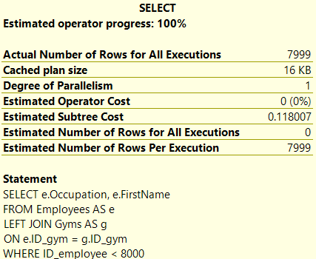 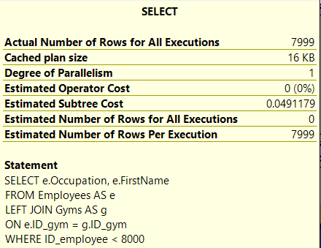

2) Предикаты

SELECT l.ExpiringDate, l.LockerNumber

FROM Lockers AS l

WHERE l.ExpiringDate BETWEEN '1960.01.01' AND '1990.01.01'

CREATE NONCLUSTERED INDEX idx4_2 ON Lockers(ExpiringDate, LockerNumber)

WHERE ExpiringDate > '1950.01.01'

SELECT l.ExpiringDate, l.LockerNumber

FROM Lockers AS l

WHERE l.ExpiringDate BETWEEN '1960.01.01' AND '1990.01.01'

DROP INDEX idx4_2 ON Lockers

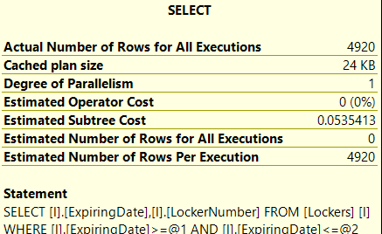 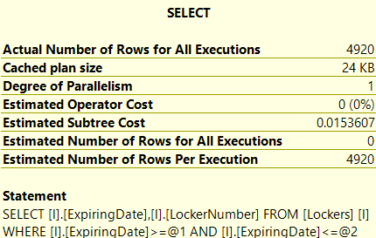

3) Работа со строками

SELECT STUFF(cl.Firstname, 2, 1, '___')

FROM Clients AS cl

WHERE ID_client < 5000

CREATE NONCLUSTERED INDEX idx4_3 ON Clients(Firstname) WHERE ID_client < 5000

SELECT STUFF(cl.Firstname, 2, 1, '___')

FROM Clients AS cl

WHERE ID_client < 5000

DROP INDEX idx4_3 ON Clients

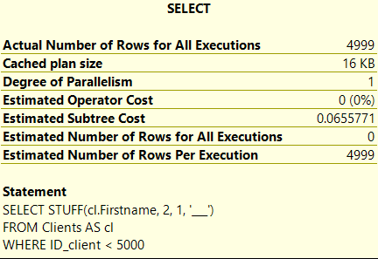 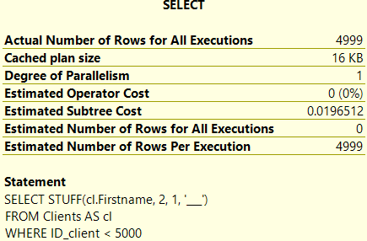

4) Дата и время

SELECT e.Firstname, e.Surname

FROM Employees AS e

WHERE DATEDIFF(year, '2024/01/01', e.BirthDate) > 25

AND BirthDate > '1990.01.01'

CREATE NONCLUSTERED INDEX idx4_4 ON Employees(BirthDate) WHERE BirthDate > '1980.01.01'

SELECT e.Firstname, e.Surname

FROM Employees AS e

WHERE DATEDIFF(year, '2024/01/01', e.BirthDate) > 25

AND BirthDate > '1990.01.01'

DROP INDEX idx4_4 ON Employees

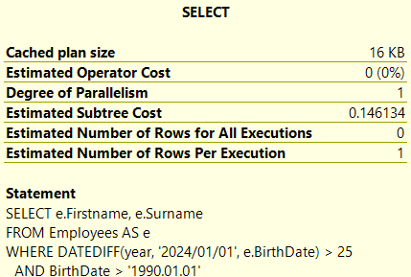 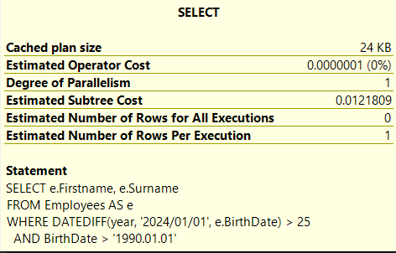

5) Группировка

SELECT g.Address, COUNT(g.OpenTime)

FROM Gyms AS g

WHERE OpenTime > '1:00:00'

GROUP BY g.Address

CREATE NONCLUSTERED INDEX idx4_5 ON Gyms(Address, Title) WHERE OpenTime > '1:00:00'

SELECT g.Address, COUNT(g.OpenTime)

FROM Gyms AS g

WHERE OpenTime > '1:00:00'

GROUP BY g.Address

DROP INDEX idx4_5 ON Gyms

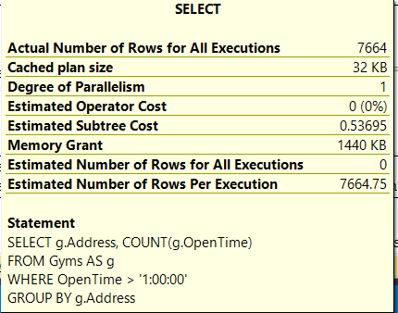 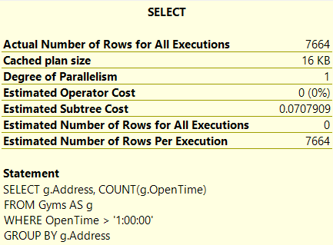

6) Вложенные запросы

SELECT tar.Title, tar.Price

FROM Tariffs AS tar

WHERE Title IN

(SELECT Title FROM Tariffs

WHERE Price > 2000 GROUP BY Title)

CREATE INDEX idx4_6 ON Tariffs(Title) WHERE Price > 2000

SELECT tar.Title, tar.Price

FROM Tariffs AS tar

WHERE Title IN

(SELECT Title FROM Tariffs

WHERE Price > 2000 GROUP BY Title)

DROP INDEX idx4_6 ON Tariffs

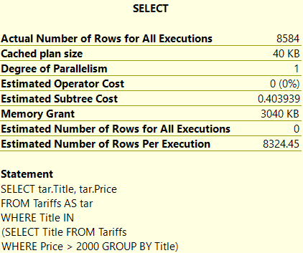 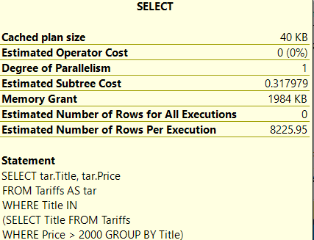

7) UNION

SELECT tar.Title, tar.Price

FROM Tariffs AS tar

WHERE tar.Price > 500 AND tar.Price < 1000

UNION

SELECT tar.Title, tar.Price

FROM Tariffs AS tar

WHERE tar.Price > 2500 AND tar.Price < 3500

CREATE NONCLUSTERED INDEX idx4_7 ON Tariffs(Price, Title) WHERE Price < 5000

SELECT tar.Title, tar.Price

FROM Tariffs AS tar

WHERE tar.Price > 500 AND tar.Price < 1000

UNION

SELECT tar.Title, tar.Price

FROM Tariffs AS tar

WHERE tar.Price > 2500 AND tar.Price < 3500

DROP INDEX idx4_7 ON Tariffs

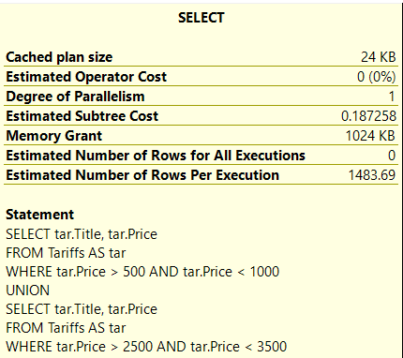 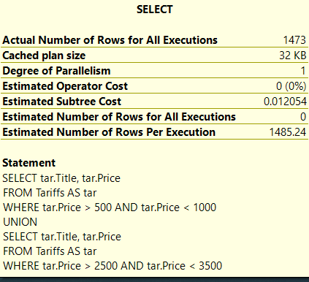

**Кластерный индекс**

1) Соединение

SELECT c1.Surname, c1.Rating

FROM Coaches_unclustered AS c1

INNER JOIN Coaches_unclustered AS c2

ON c1.ID_coach = c2.ID_coach

WHERE c1.ID_coach > 3000 AND c1.ID_coach < 4000

CREATE CLUSTERED INDEX idx_1 ON Coaches_unclustered(ID_coach)

SELECT c1.Surname, c1.Rating

FROM Coaches_unclustered AS c1

INNER JOIN Coaches_unclustered AS c2

ON c1.ID_coach = c2.ID_coach

WHERE c1.ID_coach > 3000 AND c1.ID_coach < 4000

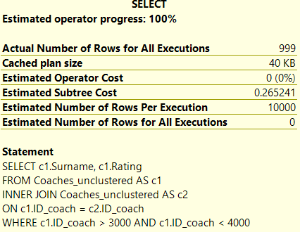DROP INDEX idx_1 ON Coaches_unclustered

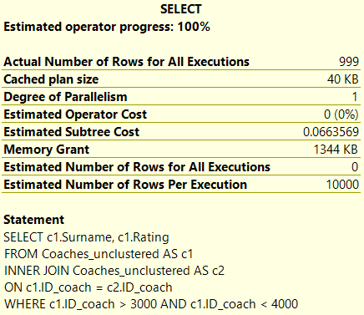

2) Операторы фильтрации

SELECT c.Firstname, c.Lastname

FROM Coaches_unclustered AS c

WHERE c.Firstname LIKE 'ааЖ%'

CREATE CLUSTERED INDEX idx_2 ON Coaches_unclustered(Firstname)

SELECT c.Firstname

FROM Coaches_unclustered AS c

WHERE c.Firstname LIKE 'ааЖ%'

DROP INDEX idx_2 ON Coaches_unclustered

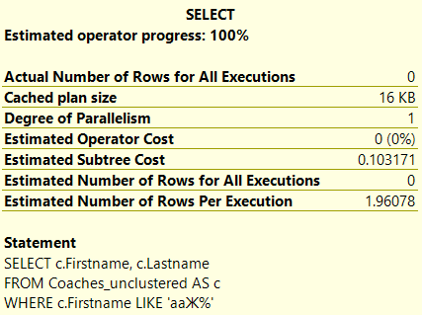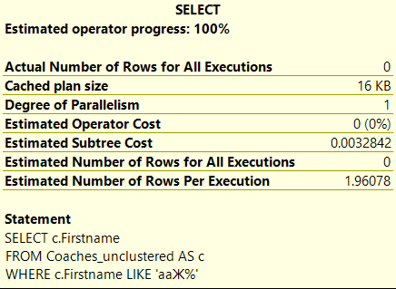

3) Строки

SELECT SUBSTRING(c.Firstname, 1, 3)

FROM Coaches_unclustered AS c

WHERE c.ID_coach > 5000

CREATE CLUSTERED INDEX idx_3 ON Coaches_unclustered(ID_coach, Firstname)

SELECT SUBSTRING(c.Firstname, 1, 3)

FROM Coaches_unclustered AS c

WHERE c.ID_coach > 5000

DROP INDEX idx_3 ON Coaches_unclustered

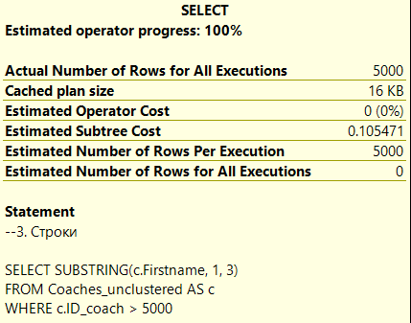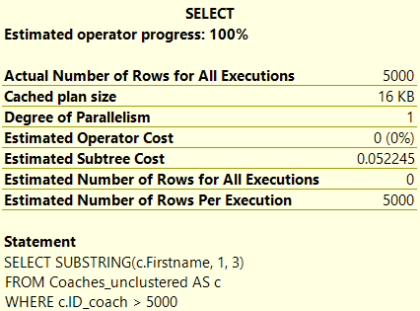

4) Дата и время

SELECT DATEDIFF(day, c.BirthDate, GETDATE())

FROM Coaches_unclustered AS c

CREATE CLUSTERED INDEX idx_4 ON Coaches_unclustered(ID_coach, Birthdate)

SELECT DATEDIFF(day, c.BirthDate, GETDATE())

FROM Coaches_unclustered AS c

DROP INDEX idx_4 ON Coaches_unclustered

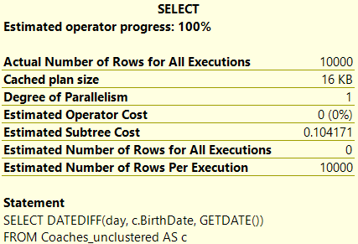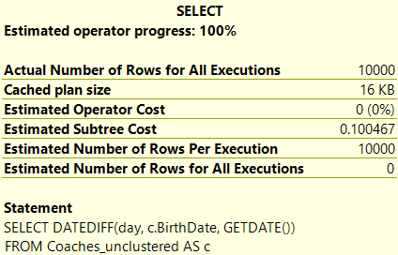

5) Агрегатные функции

SELECT c.Surname

FROM Coaches_unclustered AS c

GROUP BY Surname

CREATE CLUSTERED INDEX idx_5 ON Coaches_unclustered(Surname)

SELECT c.Surname

FROM Coaches_unclustered AS c

GROUP BY Surname

DROP INDEX idx_5 ON Coaches_unclustered

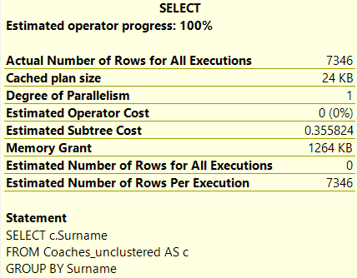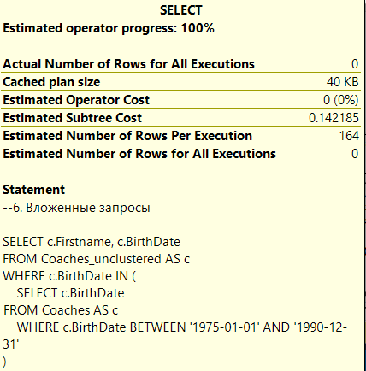

6) Вложенные запросы

SELECT c.Firstname, c.BirthDate

FROM Coaches_unclustered AS c

WHERE c.BirthDate IN (

SELECT c.BirthDate

FROM Coaches AS c

WHERE c.BirthDate BETWEEN '1975-01-01' AND '1990-12-31'

)

CREATE CLUSTERED INDEX idx_6 ON Coaches_unclustered(Birthdate)

SELECT c.Firstname, c.BirthDate

FROM Coaches_unclustered AS c

WHERE c.BirthDate IN (

SELECT c.BirthDate

FROM Coaches AS c

WHERE c.BirthDate BETWEEN '1975-01-01' AND '1990-12-31'

)

DROP INDEX idx_6 ON Coaches_unclustered

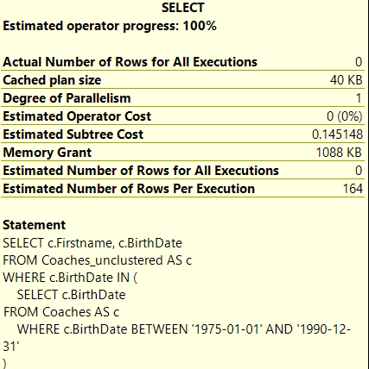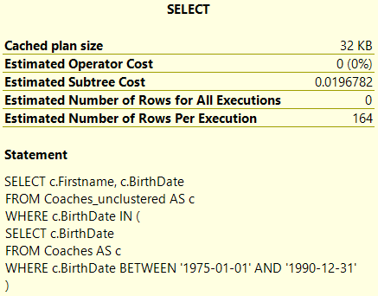

7) UNION

SELECT c.Firstname

FROM Coaches_unclustered AS c

WHERE Firstname LIKE 'А%'

UNION

SELECT c.Lastname

FROM Coaches_unclustered AS c

WHERE Lastname LIKE 'а%'

CREATE NONCLUSTERED INDEX idx_7 ON Coaches_unclustered(Firstname)

SELECT c.Firstname

FROM Coaches_unclustered AS c

WHERE Firstname LIKE 'А%'

UNION

SELECT c.Lastname

FROM Coaches_unclustered AS c

WHERE Lastname LIKE 'а%'

DROP INDEX idx_7 ON Coaches_unclustered

